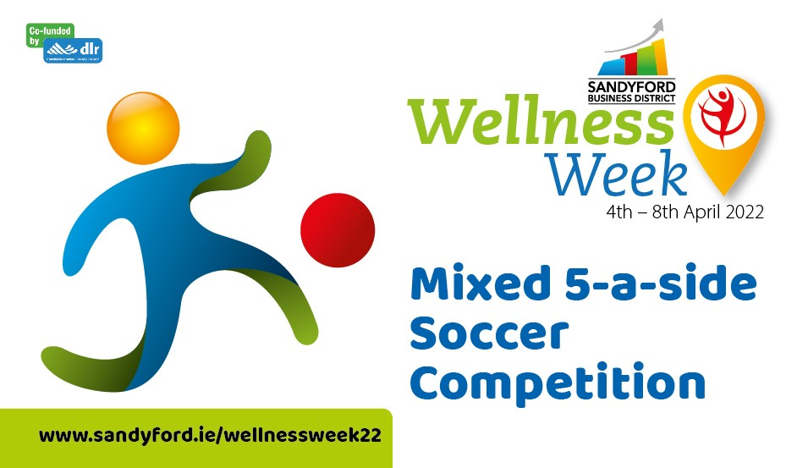

Terms and Conditions

Register your team before Thursday 31st March
Teams must be mixed (min 1 female player)
Toss a coin to decide which team goes first by a coin toss.
Players should be inside their own half for kick-off.
If a goal is scored, play will be restarted and the opposite team will kick off from the centre.
The goalkeepers can only roll out or pass the ball along the ground. When the ball is in play, there are no out of bounds lines, which means the game will continue smoothly with no stops this way.
Teams will receive 3 points for a win, 1 for a draw and zero for a loss.

How Long does a Game of 5-a-Side Football Last?
15 minutes each way with a break of 5 minutes at half time.

What about Substitutions?
You can roll your substitutions and all subs must wait outside of the pitch. Rotations are allowed throughout the game and the game will not stop for this. The player being subbed should be off the pitch before the new player comes on.

What Do you Need to Wear to Play 5-a-side Football?
If you don’t have bibs for your teams, why not arrange to wear the same colour t-shirt?
Referees
Referees will be appointed for the semi finals and finals only

The prize a €250 Me2You Gift Card. It is non-transferable, non-refundable and cannot be exchanged for any cash alternatives in whole or in part.
The promoter of this competition is Sandyford Business District, 10 Leopardstown Office Park, Burton Hall Avenue, Sandyford Business Park, Dublin 18, You can contact the Promoter in relation to the promotion by mail to this address Niamh.egan@sandyford.ie
Sandyford Business District reserves the right to cancel the competition if circumstances arise outside of its control

Every Participant Must Complete a Waiver:
Please copy and sign and email to Niamh.egan@sandyford.ie

I confirm that I am 18 years or over
I wish to participate in this competition.
I acknowledge and accept that the Activity requires a moderate level of fitness and is physically testing. I confirm that I do not know of any medical condition that I suffer from which might have the effect of making it more likely that I will be involved in any incident which could result in injury to myself, or others.
I acknowledge and accept that the Activity is potentially dangerous and that by participating in the Activity I am exposed to the possibility of personal injury or death and/or property damage and I accept this risk on my behalf
In the event of an accident involving myself I acknowledge and accept that Sandyford Business District will not be liable for any direct or indirect loss, damage or injury arising from or in connection with my participation in the Activity and I hereby waive all and any claims against Sandyford Business District in this respect and in respect of myself .
I hereby release, waive, forever hold harmless, indemnify and keep indemnified Sandyford Business District from all claims for any injury, loss or damage sustained by me arising from or in connection with the Activity and I hereby indemnify Sandyford Business District against all claims made by any other person against Sandyford Business District in respect of any injury, loss or damage arising out of or in connection with my failure to follow safety instructions and/or directions of Sandyford Business District, its management and/or staff.
I acknowledge and accept that this Form may be pleaded in the defence to any action or proceedings taken by me at any time against Sandyford Business District arising out of or in connection with my participation in the Activity.
I confirm that I am 18 years of age or older and acknowledge that I have read and fully understand the above prior to signing

Signed:__________________________________ Date:________________________

