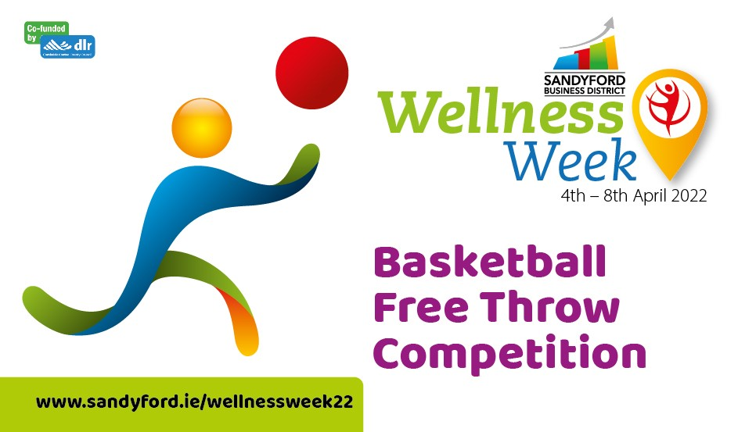
Terms and Conditions
Basketballs will be provided by SBD.
Participants are given two practice attempts before the start of the competition.
All free throws must be attempted from behind the free throw line
Participants must have both feet behind the free throw line (no part of his/her feet can touch the line from the time the ball leaves his/her hands to the point that it touches the basket—otherwise it will count as a missed shot).
Participants get 10 Free Throws
The person with the highest number of free throws out of 10 is the winner
Entry is free. If a participant wishes to have another attempt they will be charged €5 per additional attempt.
The prize is a €100 Me2You Gift Card. No cash or alternative will be offered in lieu of prize.
In the event that 2 or more participants get 10 successful throws out of 10 shots their names will be entered into a draw and the overall winner will be selected at random
The promoter of this competition is Sandyford Business District, 10 Leopardstown Office Park, Burton Hall Avenue, Sandyford Business Park, Dublin 18, You can contact the Promoter in relation to the promotion by mail to this address Niamh.egan@sandyford.ie
Sandyford Business District reserves the right to cancel the competition if circumstances arise outside of its control.
Every Participant Must Complete a Waiver:
Please copy and sign and email to Niamh.egan@sandyford.ie

I confirm that I am 18 years or over
I wish to participate in this competition.
I acknowledge and accept that the Activity requires a moderate level of fitness and is physically testing. I confirm that I do not know of any medical condition that I suffer from which might have the effect of making it more likely that I will be involved in any incident which could result in injury to myself, or others.
I acknowledge and accept that the Activity is potentially dangerous and that by participating in the Activity I am exposed to the possibility of personal injury or death and/or property damage and I accept this risk on my behalf
In the event of an accident involving myself I acknowledge and accept that Sandyford Business District will not be liable for any direct or indirect loss, damage or injury arising from or in connection with my participation in the Activity and I hereby waive all and any claims against Sandyford Business District in this respect and in respect of myself .
I hereby release, waive, forever hold harmless, indemnify and keep indemnified Sandyford Business District from all claims for any injury, loss or damage sustained by me arising from or in connection with the Activity and I hereby indemnify Sandyford Business District against all claims made by any other person against Sandyford Business District in respect of any injury, loss or damage arising out of or in connection with my failure to follow safety instructions and/or directions of Sandyford Business District, its management and/or staff.
I acknowledge and accept that this Form may be pleaded in the defence to any action or proceedings taken by me at any time against Sandyford Business District arising out of or in connection with my participation in the Activity.
I confirm that I am 18 years of age or older and acknowledge that I have read and fully understand the above prior to signing

Signed:__________________________________ Date:________________________

