**Monday 11th October 10 – 12**



**ENERGY**

**Edwin Diender**

Chief Innovation Officer, Global Energy Business Unit, Enterprise Business Group Huawei

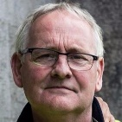

**Dudley Stewart**

Managing Director - Micro Electricity Generation Association (MEGA) & Charleville Castle – cityxchange

**John Keohane**

Verde Energy Group



**Declan Barrett**

UrbanVolt

**Tuesday 12th October 10 - 12**

**WASTE & WATER**



**Graham Colclough**

Partner UrbanDNA



**Christine Crawford**

Business & Communications Manager Irish Water

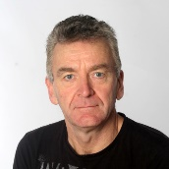

**Sean Penston**

Director of Facilities/ H&S Officer at Beacon Hospital



**Sean O’Haire**

Head of Marketing at VivaGreen Group

**Wednesday 13th October 10 – 12**

**MOBILITY**



**Jack O’Sullivan**

Founder of Modmo

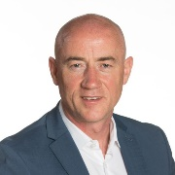

**Robert Burns**

Director of Infrastructure and Climate Change



**Sinead Farrell**

Senior Marketing Executive at Jaguar Land Rover Ireland – Spirit Motor Group

**Charlie Gleeson**

Founder & CEO at Zipp Mobility

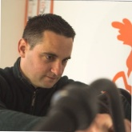

**Hugh Cooney**

CEO at Bleeper



**Graham Brennan**

Transport R&D Programme Manager at Sustainable Energy Authority of Ireland (SEAI)



**Fiona Brady**

Head of Operations (Ireland) FreeNow



**Derek Reilly**

EV Summit/ EV Review Magazine



**Páraic Carroll**

Assistant Professor in Transport Engineering at University College Dublin

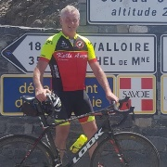

**Michael O’Boyle**

CEO Cycling Solutions Ireland

**ENVIRONMENT**

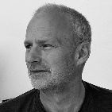

**Angus Cunningham**

Founder & CEO Scotscape Urban Greening



**Harry O’Crowley**

Dept of Agriculture



**Joanne Sheahan**

Enterprise Ireland