Letter Ref: GMC - G&D - D14 -SW - 1125

0 November 2025

Dear Customer,

Re: Sandyford – Notification of Works

Uisce Éireann is commencing works to upgrade the water infrastructure to cater for the future growth and development of the Sandyford area. These works are being carried out as part of Uisce Éireann’s Growth and Development Programme.

The project will be carried out on behalf of Uisce Éireann by GMC Utilities Group.

GMC Utilities Group will commence works on Monday, 24 November 2025.

The works involve the installation of a new trunk water main to replace the existing 14-inch main, which is currently operating at full capacity.
To deliver these works efficiently and safely a lane closure has been granted by Dun Laoghaire Rathdown County Council. A Stop/Go traffic management system will be in place along Carmanhall Road, Blackthorn Road and Burton Road at various stages during works. See overleaf for further details.

Uisce Éireann expects these works to last for approximately 5 months.

Standard working hours are 9AM to 11PM, Monday to Friday. Weekend works will be required.

We regret any inconvenience the delivery of these necessary works may cause.

For further information, please contact Johnny Cuciureanu, Community Liaison Officer with GMC Utilities Group, on 0858541594, or Uisce Éireann on 1800 278 278.

Yours faithfully,

Donal O’Connor

Programme Manager, Uisce Éireann

Growth and Development Programme

Uisce Éireann's Growth and Development Programme is a national programme of targeted investment to increase the capacity of water and wastewater infrastructure to enable social and economic growth and development, including the delivery of essential housing.

For more information, visit our website at water.ie/growth.

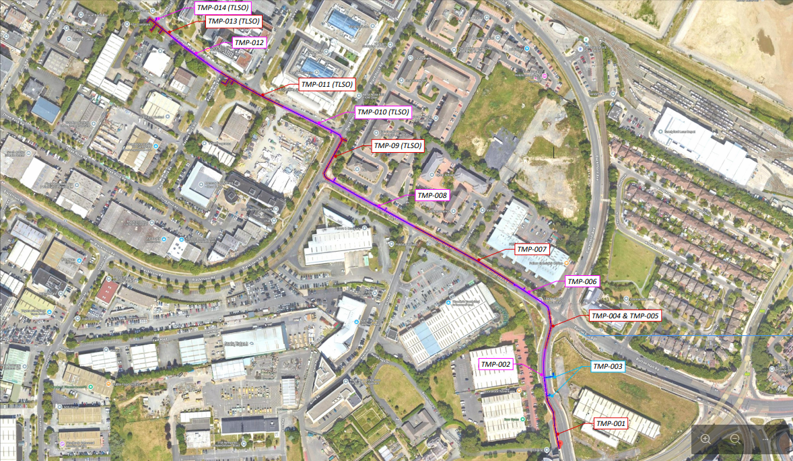

Tagairt na Litreach: GMC - G&D - D14 -SW - 1125

04 November 2025

A Chustaiméir, a chara,

Maidir le: Áth an Ghainimh – Fógra maidir le hOibreacha

Tá Uisce Éireann ag cur tús le hoibreacha chun an bonneagar uisce a uasghrádú ionas gur féidir freastal ar fhás agus forbairt amach anseo i gceantar Áth an Ghainimh. Tá na hoibreacha sin á ndéanamh mar chuid de Chlár Fáis agus Forbartha Uisce Éireann.

Cuirfidh GMC Utilities Group an tionscadal i gcrích ar son Uisce Éireann.

Cuirfidh GMC Utilities Group tús leis na hoibreacha Dé Luain, 24 Samhain 2025.

Áirítear sna hoibreacha suiteáil príomhphíobáin uisce nua chun an príomhphíobán 14-orlach atá ann cheana féin, is atá ag feidhmiú ar lánacmhainn faoi láthair, a athsholáthar.
D’fhonn na hoibreacha sin a chur i gcrích go héifeachtúil agus go sábháilte, ceadaíodh dúnadh lána ag Comhairle Contae Dhún Laoghaire Ráth an Dúin. Beidh córas bainistíochta tráchta Stop/Gluais i bhfeidhm feadh Bhóthar Halla na gCarraeirí, Bhóthar an Draighin agus Bhóthar an Bhurtúnaigh ag céimeanna éagsúla i rith na n-oibreacha. Féach lastall le haghaidh sonraí breise.

Meastar de réir Uisce Éireann go mairfidh na hoibreacha sin tuairim is 5 mhí.

Is iad na gnáthuaireanta oibre 9R.N. go 11I.N., Luan go hAoine. Beidh oibreacha le linn dheireadh na seachtaine de dhíth.

Is oth linn aon mhíchaoithiúlacht a d’fhéadfadh a bheith ina toradh ar chur i gcrích na n-oibreacha riachtanacha sin.

Le haghaidh faisnéis bhreise a fhail, déan teagmháil le Johnny Cuciureanu, Oifigeach Teagmhála Pobail le GMC Utilities Group, ar 0858541594, nó cuir glaoch ar Uisce Éireann ar 1800 278 278.

Is mise le meas,

Donal O’Connor

Bainisteoir an Chláir, Uisce Éireann

An Clár Fáis agus Forbartha

Is ionann Clár Fáis agus Forbartha Uisce Éireann agus clár náisiúnta infheistíochta spriocdhírithe chun acmhainn an bhonneagair uisce agus fuíolluisce a mhéadú d’fhonn fás agus forbairt idir shóisialta agus eacnamaíoch a chumasú, lena n-áirítear tithíocht bhunriachtanach a sholáthar.

Chun níos mó faisnéise a fháil, tabhair cuairt ar ár suíomh gréasáin ag water.ie/growth.

