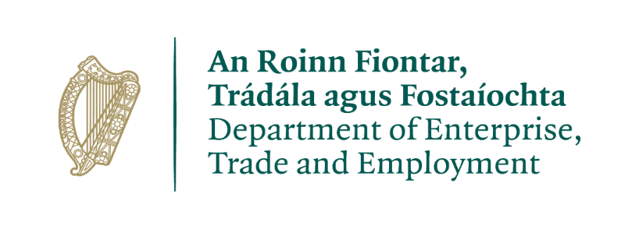 | 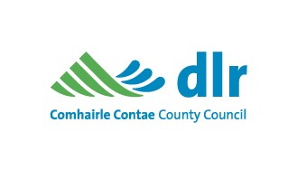

16th April 2024
Grants Available to Businesses in Dún Laoghaire-Rathdown County Council
The Increased Cost of Business (ICOB) Grant 2024 - Reminder to Register

Please Do Not Discard:
Please register to avail of the grant through www.icob.ie using your Customer ID Number and PIN.
The Deadline for registering is May 1st 2024.

Customer ID: __________
PIN: ______
Dear Ratepayer,

We are writing to you today to remind you about a new grant which may be of assistance to your business.

As part of Budget 2024, the Government agreed a package of €257 million for the Increased Cost of Business (ICOB) Grant as a vital measure for small and medium businesses. Dún Laoghaire-Rathdown County Council, funded by the Department of Enterprise, Trade and Employment (DETE), will manage the rollout of the grant to qualifying businesses.

Eligible businesses will receive a once-off grant payment. The amount of the grant is based on the value of the 2023 Commercial Rates Demand for the property your business occupies. However, it is not a Commercial Rates waiver and businesses should continue to pay their Commercial Rates Demand as normal. Your business must be rates compliant. Businesses in performing approved payment plans may be deemed to be compliant.
The main eligibility criteria are:
- Your business must be a commercially trading business currently operating from a property that is commercially rateable.
- Your business must have been trading on 1st February 2024 and you must intend to continue trading for at least three months from the date you submit your information.
- Your rates account must be up to date. Businesses in performing payment plans may be deemed to be compliant.
- Your business must be tax compliant and must possess a valid Tax Registration Number.

How much is the grant?
The grant is based on the value of the Commercial Rates Demand received by an eligible business in 2023.
- 2023 Commercial Rate Demand is <€10,000: the ICOB grant will be paid at a rate of 50% of the value of the rate Demand for 2023.
- 2023 Commercial Rate Demand is between €10,000 and €30,000: the ICOB grant will be €5,000.
- Businesses occupying a rateable property with a 2023 Commercial Rates Demand greater than €30,000 are not eligible.

How can I register for the Grant?
Businesses can use the ICOB portal which is available at mycoco.ie/icob. The portal can also be accessed through the QR code or through www.icob.ie (you will be redirected to MyCoCo). Please ensure that you have your Customer ID Number and PIN as set out at the beginning of this letter and the data below. If you need assistance in relation to the grant, please contact ICOB@dlrcoco.ie

What data do I need to register for the Grant?
The following is the data that the local authority will require to validate your eligibility for the grant:
- Your council Rate Number and the PIN provided in this letter and Rate Number which is available on your Rate Demand.
- Your legal business name and the property address including Eircode.
- Your email address and contact number.
- Your bank statement header which shows bank account details (must be dated within the last three months).
- Your Tax Registration Number (TRN)
- A Tax Clearance Certificate may be requested depending on value of grant.
- The number of employees that you employ and the business type (these are used for statistical purposes and not for the validation of the grant).
- You must self-declare that:
    - The property is not vacant.
    - Your business is tax compliant and was commercially trading at 1st February 2024.
    - You intend to continue trading for at least three months following the date of your submission.
- You must also consent to use of supplied data for the purpose of processing the grant.

When will I receive my Grant?
Following your submission to avail of your grant, Dún Laoghaire-Rathdown County Council kindly asks for your patience as we review and validate submissions throughout the county.

What is the closing date?
The deadline for businesses to confirm eligibility and upload verification details is 1st May 2024. Early registration is recommended. Payments will commence from late April 2024. Use of the portal is the most effective method for businesses seeking to avail of the grant. However, if you need help, don’t hesitate to contact us through the given email address. – ICOB@dlrcoco.ie

Where can I find out further information?
Further information on eligibility and FAQ’s is available on our website at
https://www.dlrcoco.ie/annual-budget-finance/commercial-rates/increased-cost-business-icob-grant-2024
If you have queries regarding your Commercial Rates account, contact ICOB@dlrcoco.ie. Our staff will be happy to work with you if you have any outstanding balances on your Commercial Rates account.

Yours sincerely

Rates Department
Dún Laoghaire-Rathdown County Council

